**CSS LAB NO.1**

**Task No.1**

**VM1: 192.168.100.100**

**VM2: 192.168.100.101**

**VM3: 192.168.100.102**

**Task 1.a:**

promiscuous mode is on:

**Vm1 Seed Ubuntu:**

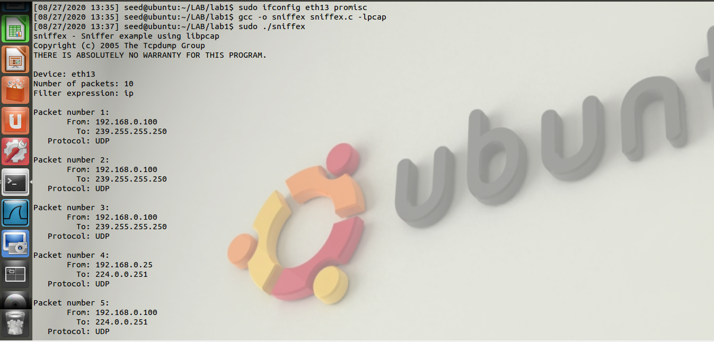



**Vm2 (Kali lunix)**

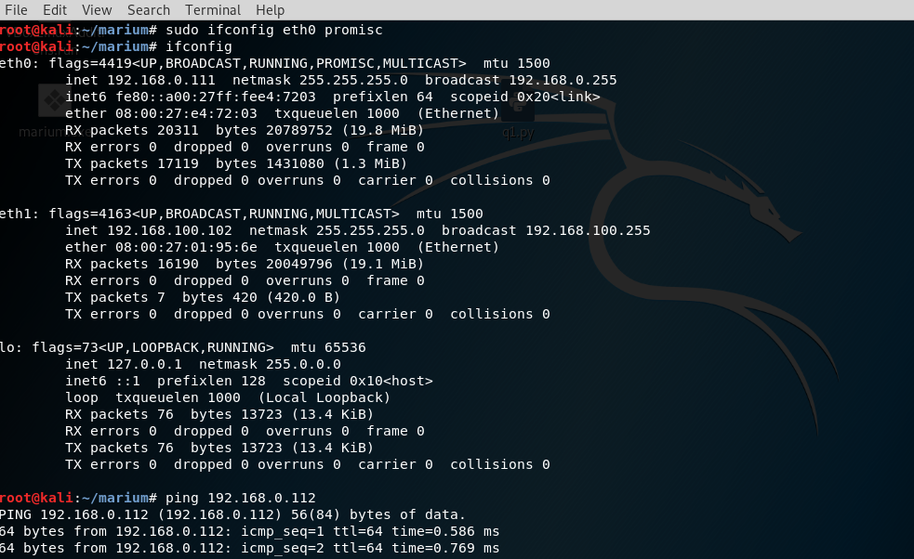

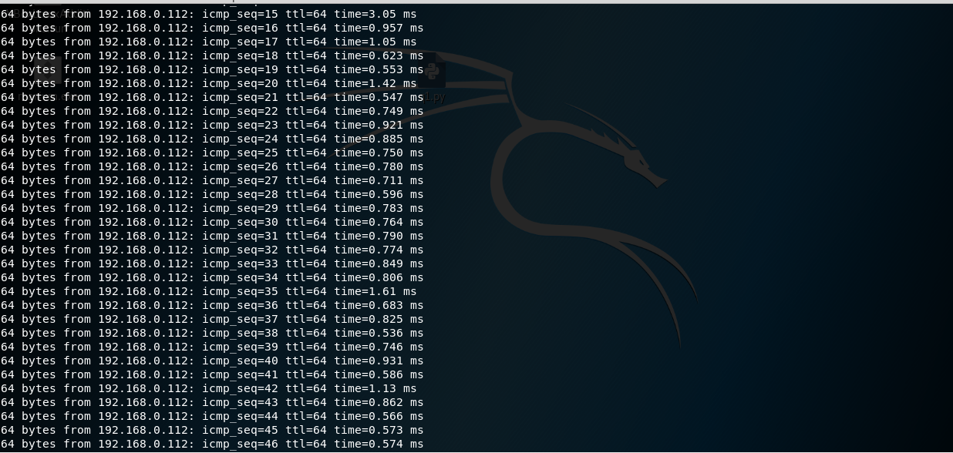

**VM3 (Ubuntu)**

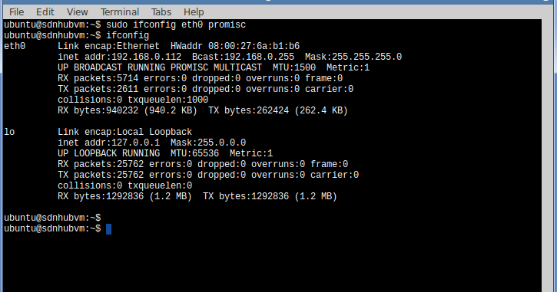

**Now pinging from Vm3 to Vm2**

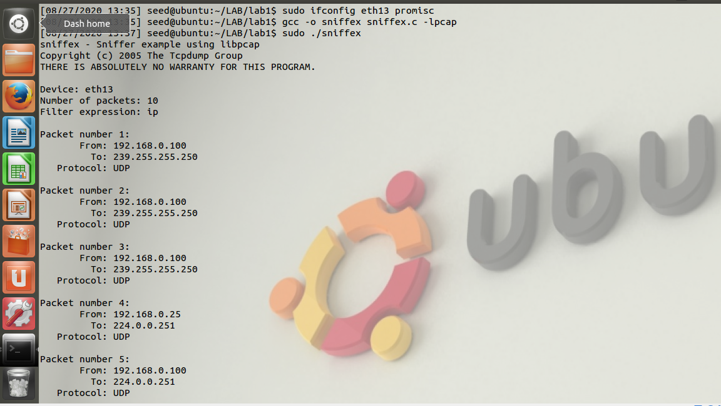

**Vm 3 (Ubutu )**

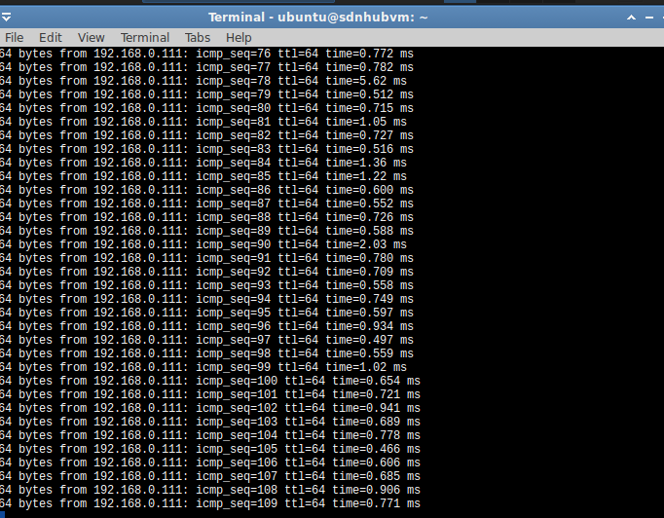

**Unsetting promiscous mode:**

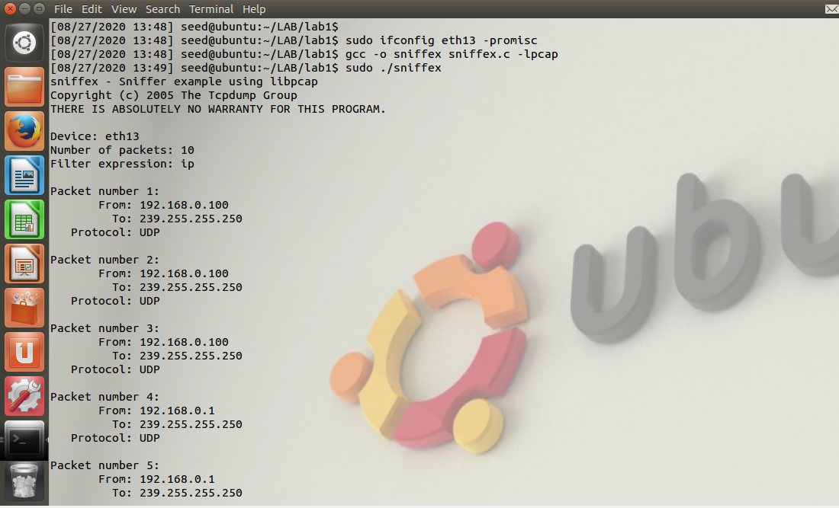

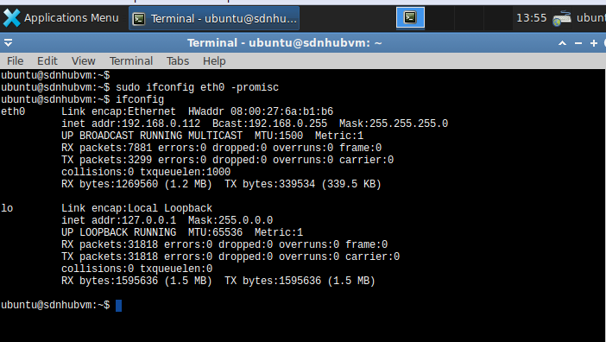**Vm2 (Ubuntu):**

**Vm 3(Kali Lunix):**

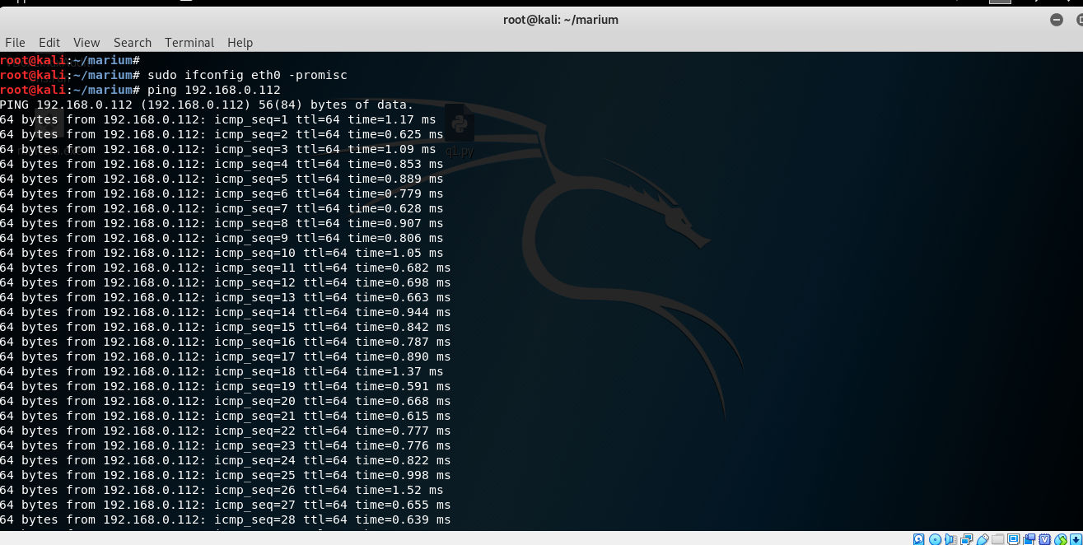

**Task 1.b:**

**First set machine in** promiscous mode  **.Using command sudo ifconfig eth0 promisc then open wiresharkand ping vm2 to vm3 to capture packet b/w them**

**VM2 kali lunix**

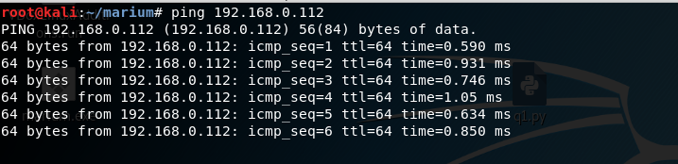

**TASK NO.2**

**Attacker machine**

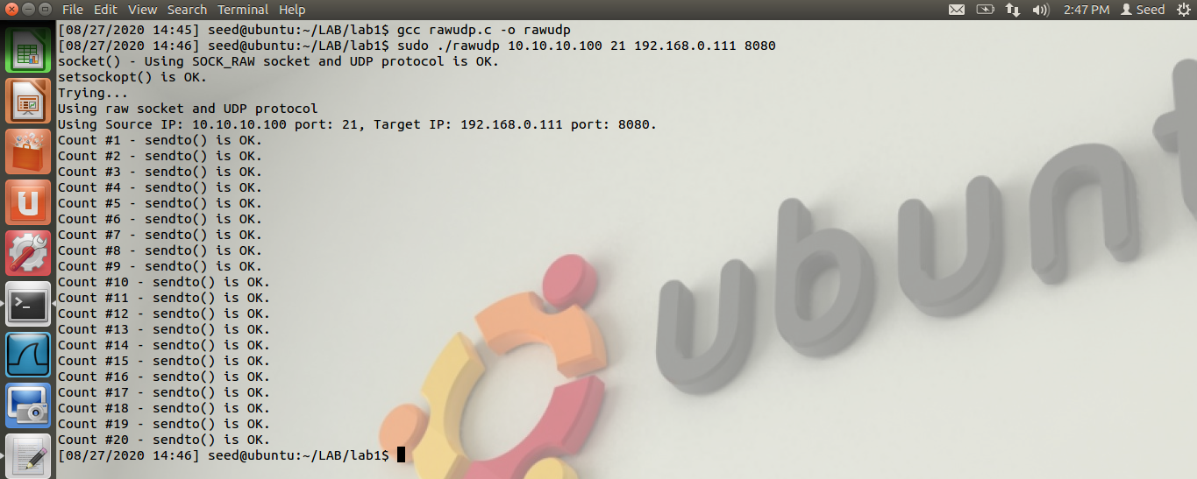

**Vctim**

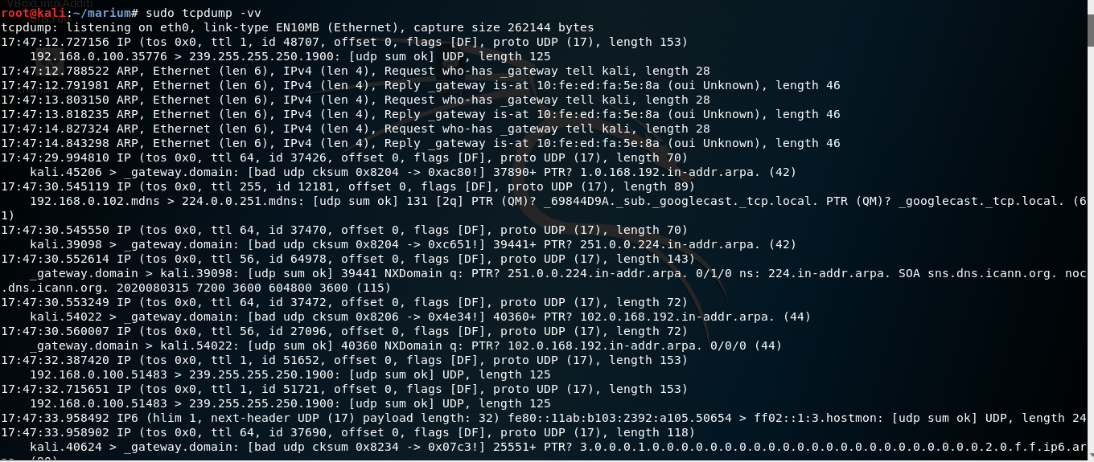

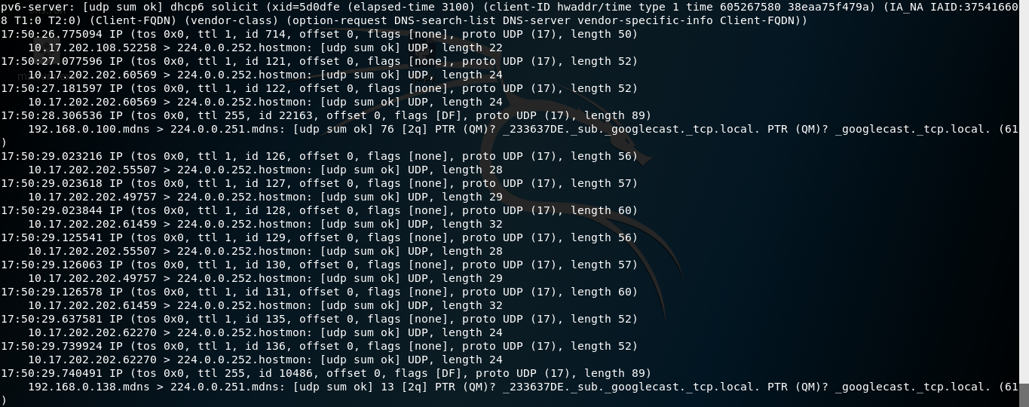

**2nd**

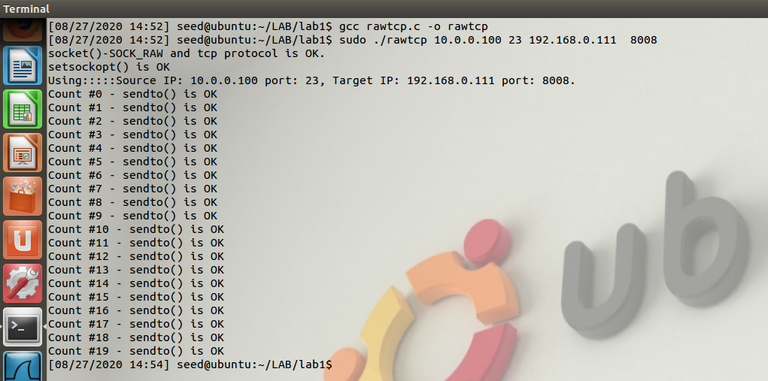

**Victim**

